50 Chemical Elements

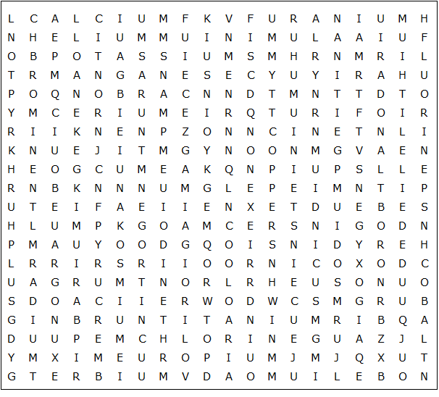

calcium krypton mercury sulphur terbium uranium lithium
zinc sodium argon boron radon xenon gold iron lead einsteinium aluminium magnesium manganese neptunium potassium chromium europium hydrogen nitrogen nobelium platinum titanium tungsten chlorine fluorine arsenic bromine
barium carbon cerium cobalt copper curium helium tin
indium iodine nickel osmium oxygen radium silver neon
50 Chemical Elements

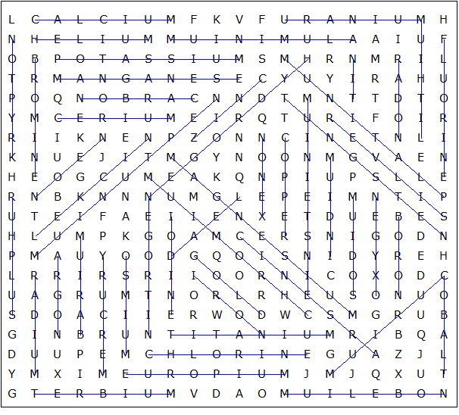

This puzzle was created in seconds using Toolbox, available for only £10 from discoveryeducationalsoftware.co.uk

